ＪＯＫＥＲ

ＪＯＫＥＲ

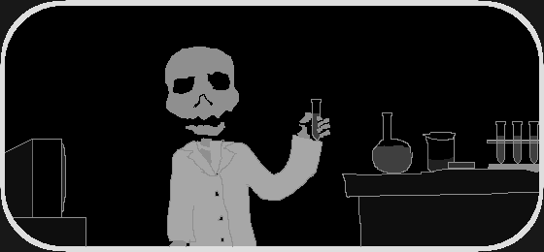
ＪＯＫＥＲ

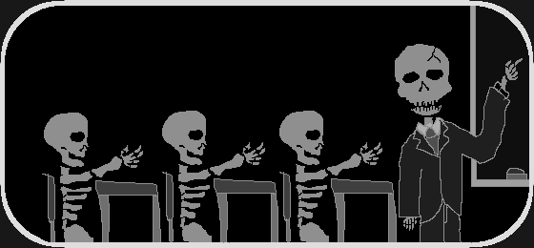

ＪＯＫＥＲ

ＪＯＫＥＲ

